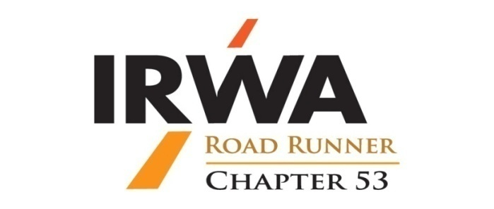

IRWA53.org

January 10, 2020 – Weck’s on Osuna – 11:45 AM

Amy Griffin, President  (505) 404-5828  Email:agriffin@sandovolcountynm.gov | Irwa53.org | Tim Solinski, Vice President  (505) 242-4848  Email: tims@auiinc.net
Deanna Miglio, SR/WA, Treasurer  (505) 224-1650  Email: dmiglio@bernco.gov |  | Meghan Bayer, Secretary  (505) 228-0902  Email: mbayer@tierra-row.com

- Call to Order:

- Introductions:

- Approval of Agenda:

- Approval of Meeting Minutes:

- Committee Reports:

- Treasurer – Deanna Miglio, SR/WA

- Membership – Marissa Trujillo
  - Spring 2020 Membership Drive

- Education –Meghan Bayer
UPCOMING COURSES
Course | Date | Coordinator | Instructor
Course 421 – Valuation of Partial Acquisitions  in Albuquerque | 1/21-24/2020 | Amy Griffin | Dalton Vann
Course 604 – Environmental Due Diligence and Liability  in Albuquerque | 4/16/2020 | Meghan Bayer | Fred Walasavage

Discussion of offering courses:
  - 603 Understanding Environmental Contamination in Real Estate
  - 900, 901 or 902 Principles of Real Estate Engineering, Engineering Plan Development, Property Descriptions
- Professional Development – Deanna Miglio, SR/WA
  - Cilicia Villegas, City of Las Cruces, RWP Certification
  - Monica Rodriguez, Bernalillo County, RWA Certification
  - Chris Sanchez, Bernalillo County, RWA Certification
  - Deanna Miglio, SR/WA, Bernalillo County, SR/WA Recertification

- Old Business:

- Region 9 Spring 2020 Forum
  - Volunteer Committee
  - Social Event
- Chapter Bylaw revision – Presentation of proposed revisions

- New Business:
  - National Education Conference, Minneapolis, MN, June 21-24, 2020
  - Summer Social

- Announcements:

- Adjourn:

